Selection Statements

Lecture 3 Assignments

1. The following if statement is unnecessarily complicated. Simplify it as much as possible. (Hint: The entire statement can be replaced by a single assignment.)

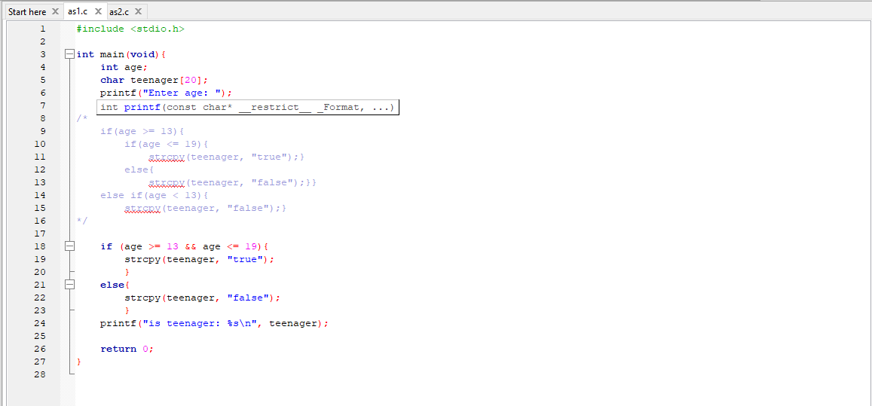

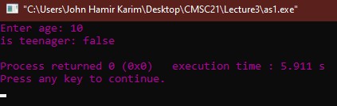

2. Write a C program that does the following:

Enter a two-digit number: 25

Number entered in words: twenty-five

Github link: https://github.com/HelloCigar/CMSC21